INF 286 Instructor Dr. Seth Adjei
Assignment #3 Last Name: First Name:

Grade:
Comment:
Assignment 3: Configuring Color and Text with CSS

Problem 1 (15%)
Create a web page:
- That includes an unordered list describing at least three advantages of using CSS (3%).
- The text CSS Advantages should be contained within <h1> tags (2%).
- This page should include a hyperlink to the W3C Web site (2%);
- Write the HTML code so that one of the advantages is configured to be a class called news (4%);
- Place an email link to yourself on the Web page (2%);
- This web page should use the external style sheet called ex3.css (2%).
- Save the page as advantage.html
- Submit this source code file.

Problem 2 (15%)
Create a web page:
- That includes an unordered list describing at least three disadvantages of using CSS (hint: you can search disadvantages of using CSS from online resources) (3%).
- The text CSS Disadvantages should be contained within <h1> tags (2%).
- This page should include a hyperlink to the W3C Web site (2%);
- Write the HTML code so that one of the disadvantages is configured to be a class called news (4%);
- Place an email link to yourself on the Web page (2%);
- This web page should use the external style sheet called ex3.css (2%)
- Save the page as disadvantage.html
- Submit this source code file.

Problem 3 (20%)
Create an external style sheet (call it ex3.css) to format as follows:
- Document background color of white (3%);
- Document text color of #000099 (3%);
- Document family of Arial, Helvetica, or sans-serif (3%);
- Hyperlinks should have a background color of grey (#CCCCCC) (3%);
- <h1> elements should use the Times New Roman font with black text color (3%).
- The news class should use red italic text (3%).
- Save it as ex3.css (1%);
- Submit this source code file (1%).

Problem 4 (10%)
Launch a browser and display both web pages created in Problem 1 and 2. Both of them use the formatting configured in ex3.css
- Paste the computer screen picture into the assignment WORD document here after you display advantage.html (Hint: press shift+PrintScreen key to copy the screen) (5%);

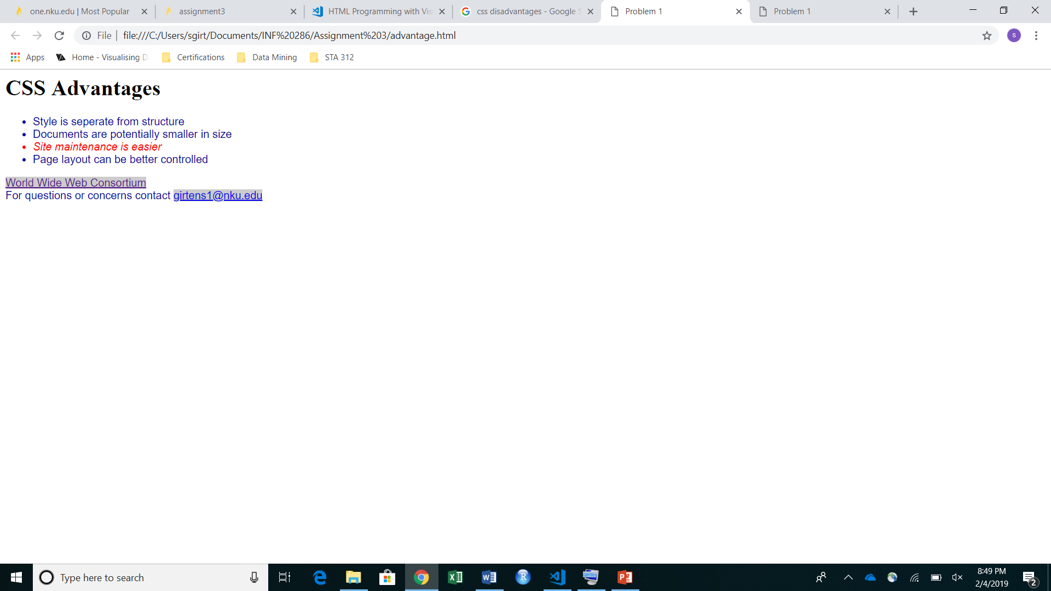
- Paste the computer screen picture to the assignment WORD document here after here you display disadvantage.html(Hint: press shift+PrintScreen key to copy the screen) (5%).

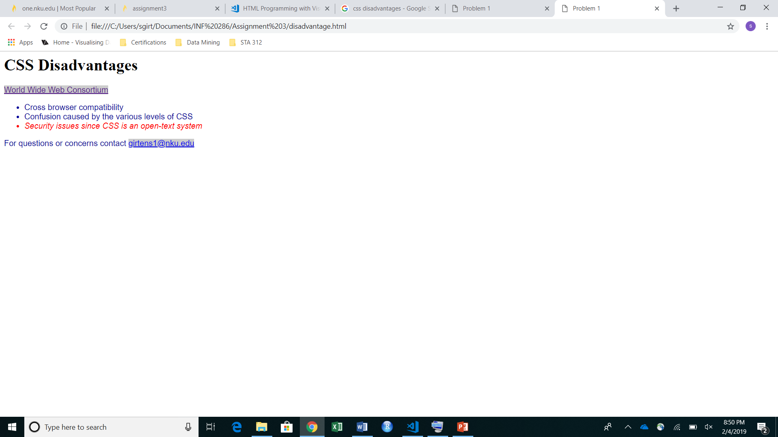
Problem 5 (20%)
Change the configuration of the external style sheet (ex3.css) created in Problem 3 to format as follows:
- Document background color of black (6%);
- Document text color of white (6%);
- <h1> text color of gray (#CCCCCC); (6%)
- Save the file as ex3_5.css (1%);
- Submit this source code file (1%) .

Problem 6 (10%)
Change the two web page files, advantage.html and disadvantage.html, so that they both use the formatting configured in ex3_5.css.
- Save these two files as advantage_6.html and disadvantage_6.html (5%);
- Submit these two web page files;
- Display each of these two new Web pages in a Web browser, and paste the computer screen picture into the assignment WORD document here (5%) (Hint: press shift+PrintScreen key to copy the screen).

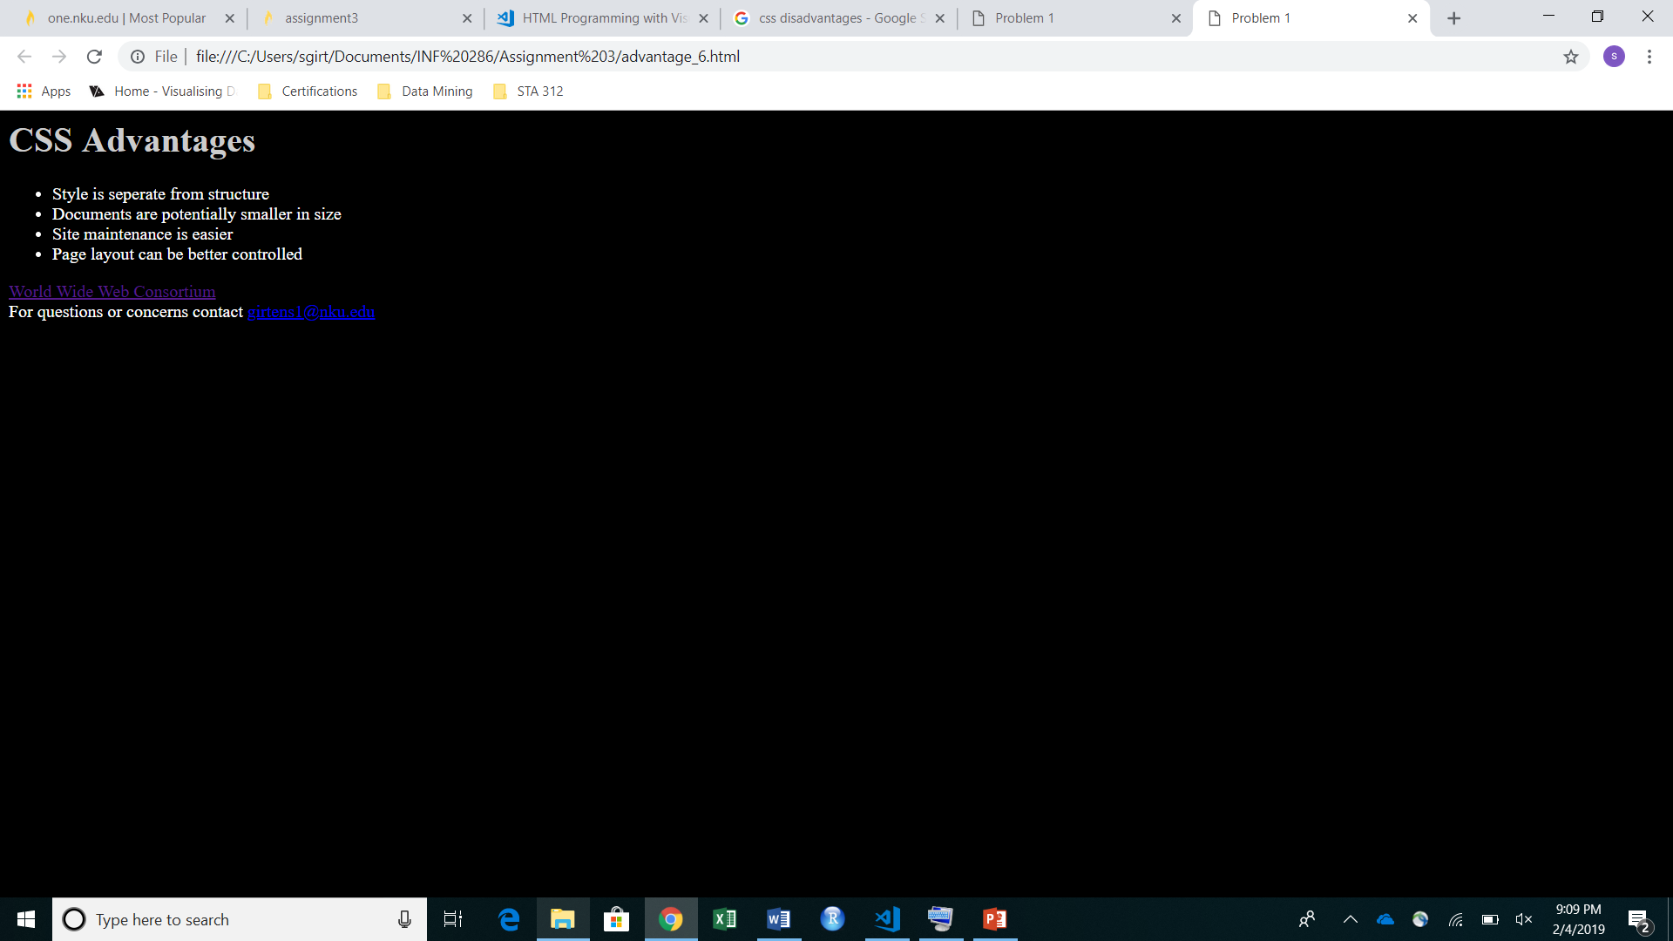
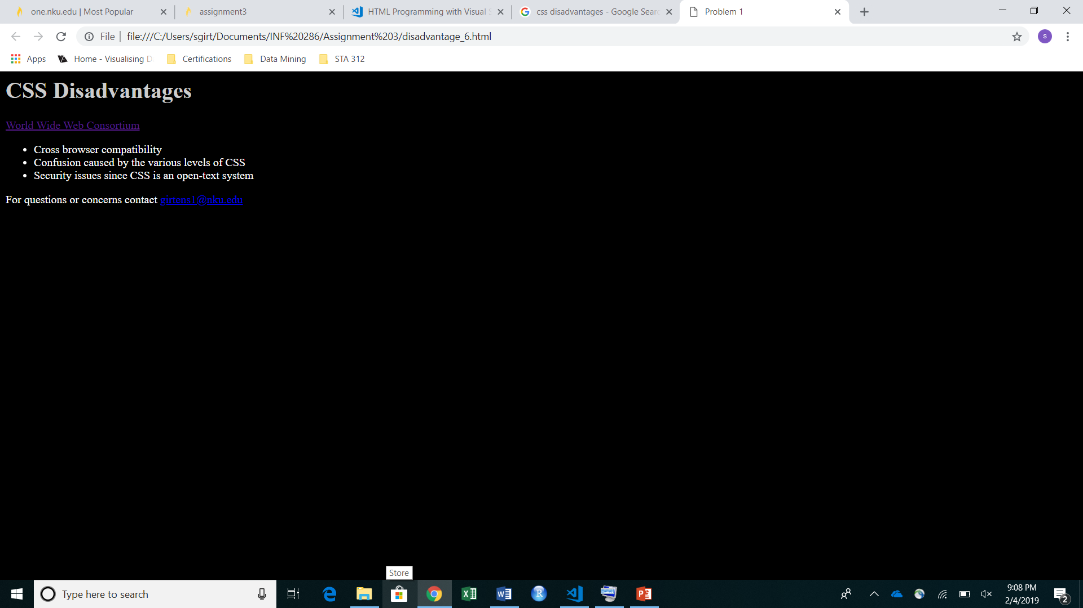

Problem 7 (10%)
Modify the advantage_6.html file to use an inline style:
- <h1> text color of red and save the file as advantage_7.html (5%);
- Submit this file;
- Display this file in a Web browser, and paste the computer screen picture into the assignment WORD document here (5%) (Hint: press shift+PrintScreen key to copy the screen).
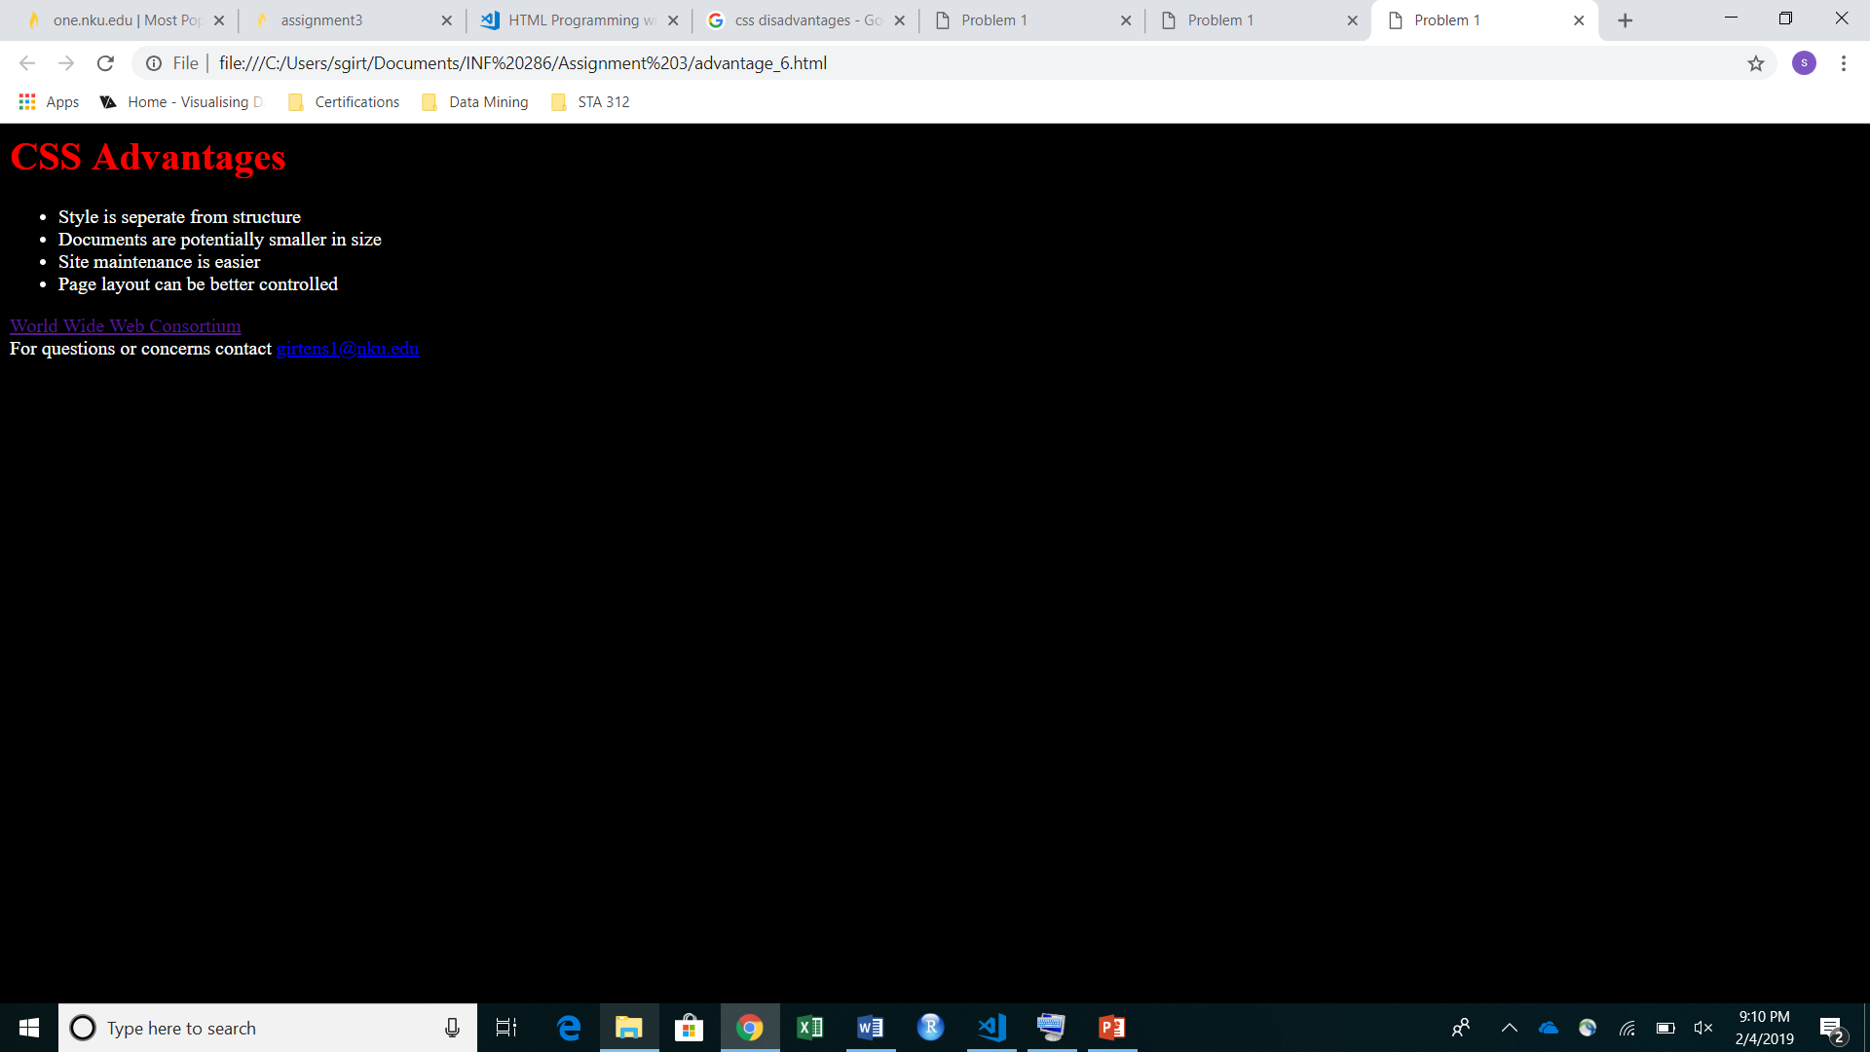

Your source code should be carefully indented and validated using the markup validation service offered by W3C at http://validator.w3.org and CSS Validation Service offered by W3C
http://jigsaw.w3.org/css-validator

Please remember to compress all your files into one zipped file and modify its name as YourLastName_YourFirstName_Assignment3.zip, and submit only the zipped file to the Canvas.

